**Descriptive Statistics and Probability**

1. Look at the data given below. Plot the data, find the outliers and find out $μ, σ, σ^{2}$

|  |  |
| --- | --- |
| Name of company | Measure X |
| Allied Signal | 24.23% |
| Bankers Trust | 25.53% |
| General Mills | 25.41% |
| ITT Industries | 24.14% |
| JPMorgan & Co. | 29.62% |
| Lehman Brothers | 28.25% |
| Marriott | 25.81% |
| MCI | 24.39% |
| Merrill Lynch | 40.26% |
| Microsoft | 32.95% |
| Morgan Stanley | 91.36% |
| Sun Microsystems | 25.99% |
| Travelers | 39.42% |
| US Airways | 26.71% |
| Warner-Lambert | 35.00% |

Answer is on the Google Colab file attached herewith.

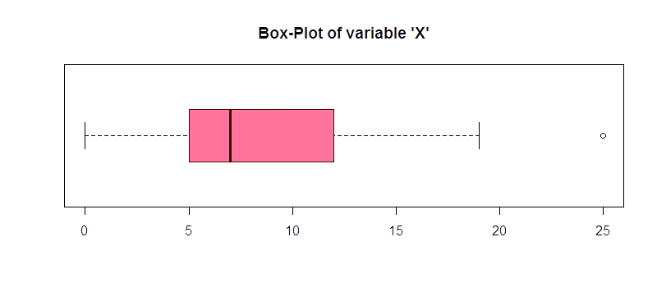

Answer the following three questions based on the box-plot above.

1. What is inter-quartile range of this dataset? (Please approximate the numbers) In one line, explain what this value implies.

**Ans:** (First Quantile Range) Q1 = 5,

(Second Quartile Range) = 7,

(Third Quantile Range) Q3 = 12

(Inter-Quartile Range) IQR = Q3 – Q1 = 12 – 5 = 7

Second Quartile Range is the Median Value

1. What can we say about the skewness of the dataset?

**Ans:** Right-Skewed median is towards the left side. It is not normal distribution.

1. If it was found that the data point with the value 25 is actually 2.5, how would the new box-plot be affected?

**Ans:** If the data point would have been 2.5 instead of 25, the data would have no outliers and the positive skewness which is currently showing will reduce and the data will be normally distributed.

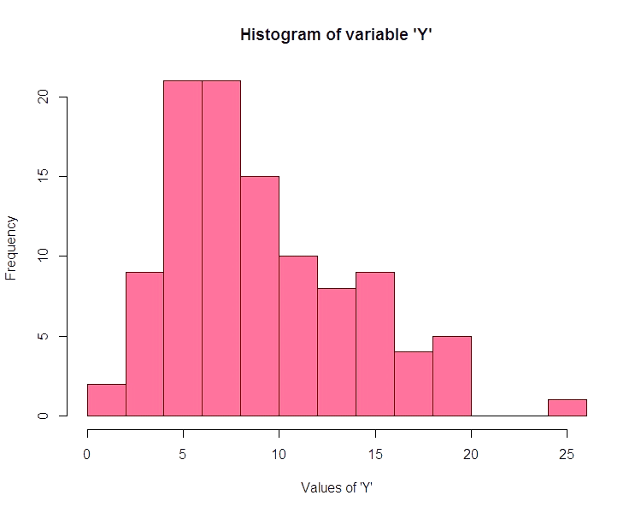3.

Answer the following three questions based on the histogram above.

* 1. Where would the mode of this dataset lie?

**Ans:** The mode of this data lies between 5-10 and 4-8, approximately.

* 1. Comment on the skewness of the dataset.

**Ans:** The data is right skewed. Mean > Median > Mode

* 1. Suppose that the above histogram and the box-plot in question 2 are plotted for the same dataset. Explain how these graphs complement each other in providing information about any dataset.

**Ans:** The histogram and the box plot have outliers in the data. Both are right skewed.

Median is visible in box plot and Mode is visible in Histogram.

1. AT&T was running commercials in 1990 aimed at luring back customers who had switched to one of the other long-distance phone service providers. One such commercial shows a businessman trying to reach Phoenix and mistakenly getting Fiji, where a half-naked native on a beach responds incomprehensibly in Polynesian. When asked about this advertisement, AT&T admitted that the portrayed incident did not actually take place but added that this was an enactment of something that “could happen.” Suppose that one in 200 long-distance telephone calls is misdirected. What is the probability that at least one in five attempted telephone calls reaches the wrong number? (Assume independence of attempts.)

**Ans:** If 1 out of 200 long distance call got misrouted, below is the probability –

* Probability of the calls getting misdirected, X = 1/200
* Probability of the calls NOT getting misdirected, Y = 1-1/200 = 199/200 = 0.995

The probability for at least one in five attempted telephone calls connects with a wrong number.

N=5

P=1/200

Q=199/200

P(x)= at least one in five attempted telephone calls connects with a wrong number

P(x) = ⁿCₓ pˣ qⁿ⁻ˣ

P(x) = (nCx) (p^x) (q^n-x) # nCr = n! / r! * (n - r)!

P (1) = (5C1) (1/200) ^1 (199/200) ^5-1

P (1) = 0.0245037

1. Returns on a certain business venture, to the nearest $1,000, are known to follow the following probability distribution

|  |  |
| --- | --- |
| x | P(x) |
| -2,000 | 0.1 |
| -1,000 | 0.1 |
| 0 | 0.2 |
| 1000 | 0.2 |
| 2000 | 0.3 |
| 3000 | 0.1 |

E(X) =Sum X.*P(X) | E(X^2) =X^2*P(X)

|  |  |
| --- | --- |
| -200 | 400000 |
| -100 | 100000 |
| 0 | 0 |
| 200 | 200000 |
| 600 | 1200000 |
| 300 | 900000 |

Total: 800 2800000

1. What is the most likely monetary outcome of the business venture?

**Ans:** The most like monetary outcome of the business venture is $2,000 for which the probability is 0.3 which is the maximum as compared to others.

1. Is the venture likely to be successful? Explain.

**Ans:** Yes, the probability that the venture will make more than 0 or a profit is -

p(x>0) +p(x>1000) +p(x>2000) +p(x=3000) = 0.2+0.2+0.3+0.1 = 0.8.

This states that there is good 80% chance for this venture to make profit.

1. What is the long-term average earning of business ventures of this kind? Explain.

**Ans:** The long-term average is expected value = Sum (X * P(X)) =$800 and that is an average income.

1. What is the good measure of the risk involved in a venture of this kind? Compute this measure

**Ans:**  P(loss) = P(x= -2000)+P(x=-1000)=0.2. So, the risk associated with this venture is 20%.